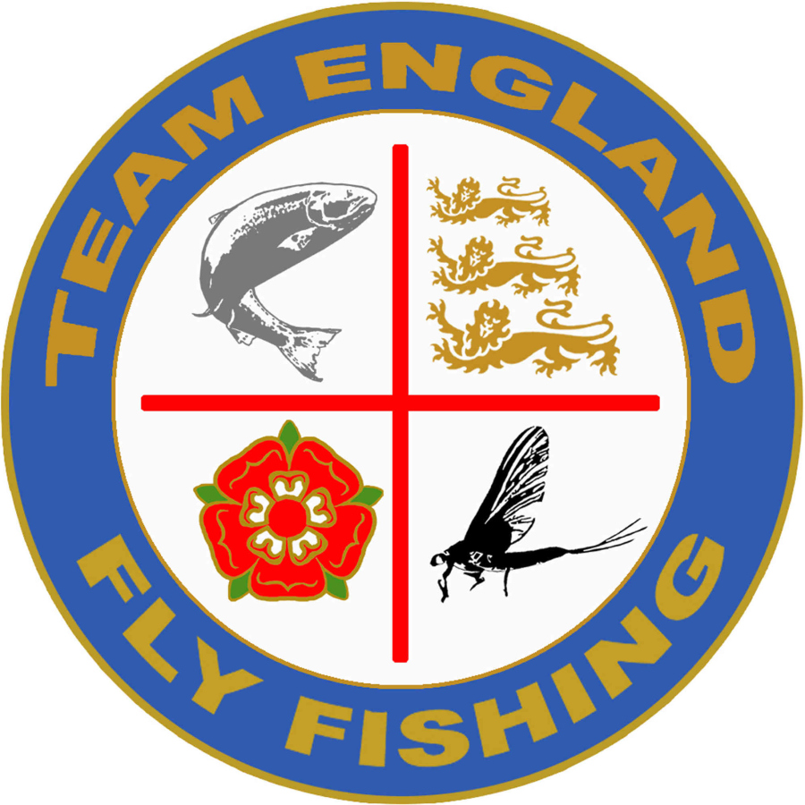
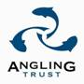

Tuesday 3rd November 2015

Opportunity to join Angling Trust Team England Fly Fishing Competitions Committee

The Angling Trust is inviting experienced, passionate and dedicated volunteers to support and deliver domestic and international game angling events through its Team England Fly Fishing Competitions Committee.
In 2014 Team England Fly Fishing (TEFF) fully integrated within the Angling Trust Competitions structure to create Angling Trust Team England Fly Fishing (AT TEFF). To ensure a smooth changeover during this period a Transition Plan was laid out by the committee, the final stages of the plan called for open recruitment process for all volunteer roles within the new AT TEFF structure.
The AT TEFF committee will lead the development of competitive fly fishing in England through delivery of its National Championships and International performance in International Fly Fishing Association (IFFA), FIPS-Mouche competitions and the 4 & 5 Nations Organising Committees.
Clive Collier, AT TEFF Chairperson said "As part of our continuing transition, Team England Fly Fishing are facing many challenges but also see many exciting opportunities. This is why we are looking for people with the vision, attributes and skills to help AT Team England Fly Fishing achieve our ambition of being the No1 Fly Fishing Nation in the World."
Volunteer roles include World and European Team Managers, 5 Nations, Rivers and Bank Team Managers, Loch Style, Rivers and Bank International Coordinators, Coaching & Development Pathway Manager, Loch Style Qualifier and National Coordinators, Bank Qualifier and National Coordinators, Rivers Qualifier and National Coordinators.
Anyone interested in getting involved can find role descriptions, person specification and application form on the Angling Trust website www.anglingtrust.net/vacancies. Closing date for applications is Friday 18th December 2015. Appointments will be made by 31st January 2016.
Further information can be obtained through Ben Thompson (Senior Competitions & Talent Development Manager) on 07854 240 177 or through Stuart Wardle (AT TEFF Governance Secretary) on 07904 278 889
How to Apply Applicants should complete an application form and diversity monitoring form available at www.anglingtrust.net/vacancies and send them marked "Personal" to:
Ben Thompson Angling Trust Strelley Hall Strelley Nottingham NG8 6PE or via email to ben.thompson@anglingtrust.net
ENDS

NOTES TO EDITOR The Angling Trust is the National Governing Body for angling in England and represents all coarse, game and sea anglers and angling.
The Angling Trust is supported by Sport England and the Environment Agency. Working with key partners, the Angling Trust aims to establish an infrastructure to develop the sport of angling within England. This includes working alongside national, regional and local angling and non-angling organisations.
For further information contact: Talent Development & Senior Competitions Manager Ben Thompson 07854 240 177 ben.thompson@anglingtrust.net www.anglingtrust.net

